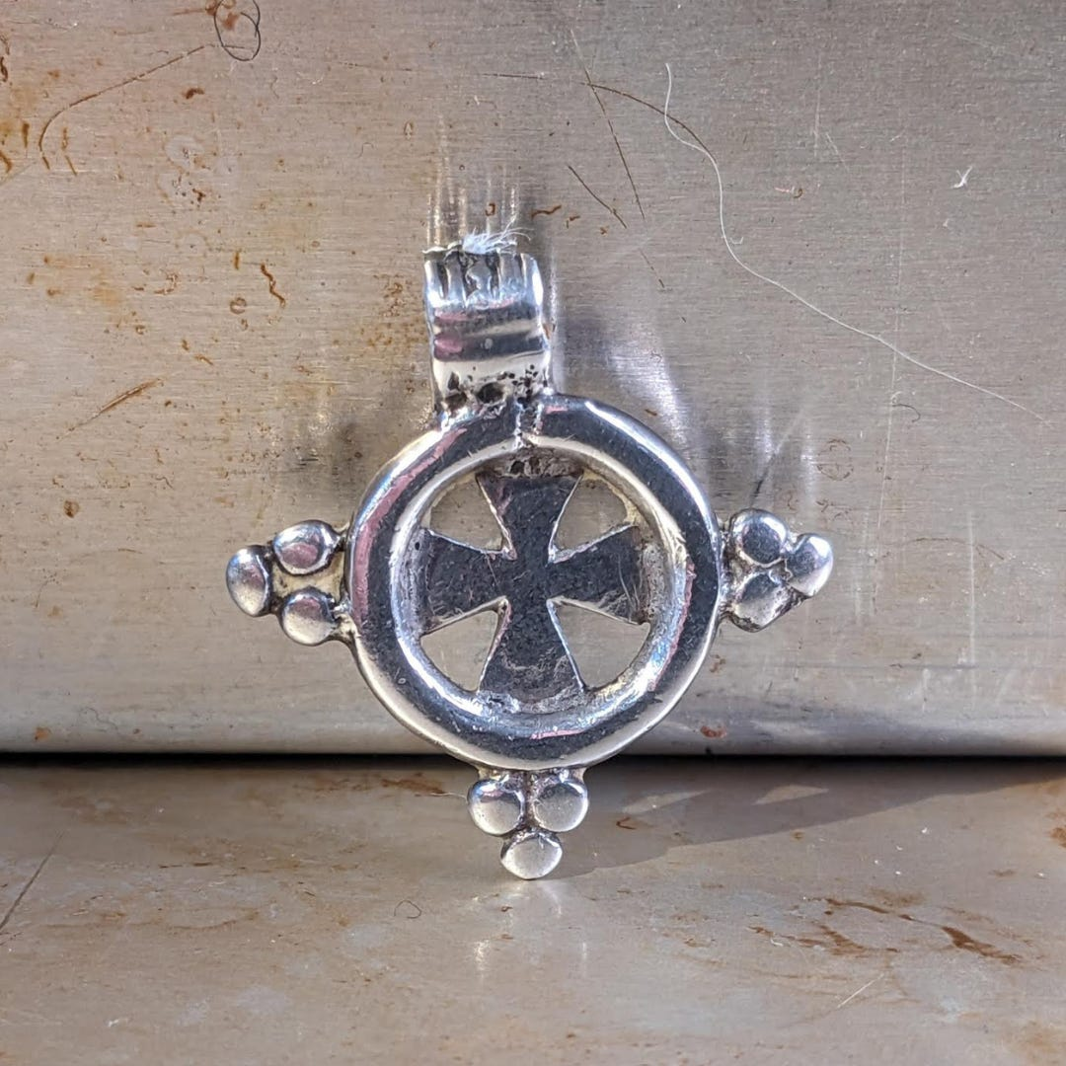

At the age of 10, when I learned to water ski on the Aegean Sea, I proudly wrote to tell my grandfather. He wrote back to say he’d learned too, on the East River. He and his friends, he said, would take a pickle barrel, pry apart its wooden slats and tie them to their feet with rope. Another friend then hopped into a rowboat and rowed really, really fast while the skier, tethered again by a rope, followed behind. What I took away from this patently absurd story wasn’t a sense of one-upmanship but that my grandfather loved me and always would, no matter how far from him my experiences might take me.
Robert T. Freeman Jr. grew up in 1930s Harlem, where it was a badge of honor to perfect a joke, a toast or a tall tale. Long and lean, honey-colored and handsome, Grampa was known as “The Harlem Hawk.” Even in his youth he displayed a proclivity for numbers, and in the late 1940s he enrolled in Lincoln University, a historically black college in Pennsylvania, where he majored in mathematics. At Lincoln he met a classmate, Francis Nkrumah, who would go on to become the first prime minister of Ghana.
In 1955, Nkrumah, by then known as Kwame Nkrumah, sent out a call to the Black diaspora, urging them to return and help him build a new African nation. My grandfather responded, expatriating to what was then the Gold Coast, a British colony, and starting a business providing health insurance, pension plans and educational funds to the newly Africanized civil service. Five years after Ghana became independent, Nkrumah nationalized the company; renamed the State Insurance Corporation, it still exists today. As its first managing director, my grandfather helped insure Ghana’s military, railroads and airlines.
Later, he would take his expertise to Ethiopia, where he worked for Haile Selassie. It was in Ethiopia that he began collecting Coptic crosses. I think he appreciated their beauty and great historical resonance, the Coptic Church being one of the oldest Christian denominations in the world. Many of the crosses, he eventually donated to the Smithsonian and to Lincoln University, but he kept his favorites in a custom-made, varnished-wood-and-glass display case that also served as a coffee table in the living room of his Washington D.C. condo.
Five p.m. in my grandfather’s living room was story time, facilitated by his evening martini. A slight shift in the pitch of his voice signaled the start of a tall tale—about my grandmother, maybe, or the Coptic cross that was hollow inside (“for the priest’s poison,” he liked to say). I sat beside him, listening to his voice, breathing in the sandalwood and lavender scent of his cologne, looking at the crosses, especially this compact and elegant one, my favorite.
After a while he’d set down his cocktail and chuckle—the chuckle signaling the arrival, finally, of the truth, though to me the truth seemed more absurd than some of his tales. He told how the British delayed his Ghana entrance visa, how they spread rumors that his company was insolvent, how they dropped leaflets over Accra to warn people of the American hustler who would abscond with their money. In many ways independence had been granted in name only, as the British and their counterparts resisted losing their cash cows. This is what Nkrumah was referring to when he introduced the term neocolonialism to describe the situation in Ghana.
Living in New England, going to a mostly white private school, I saw little of African-American history in my surroundings or textbooks—but my grandfather was historical abundance in human form. After he died, in 2001, I hoped to inherit the cross I associated with his stories and his voice—that voice shaped by the Harlem Renaissance, African nationalism and our own family’s journey through America’s treacherous past. I was told the cross had gone to a cousin. But years later I discovered it in a bin of discards in my parents’ home. How it got there I’ll never know. It just shined up at me like the perfect end to an outlandish tale.
—Eva Freeman

